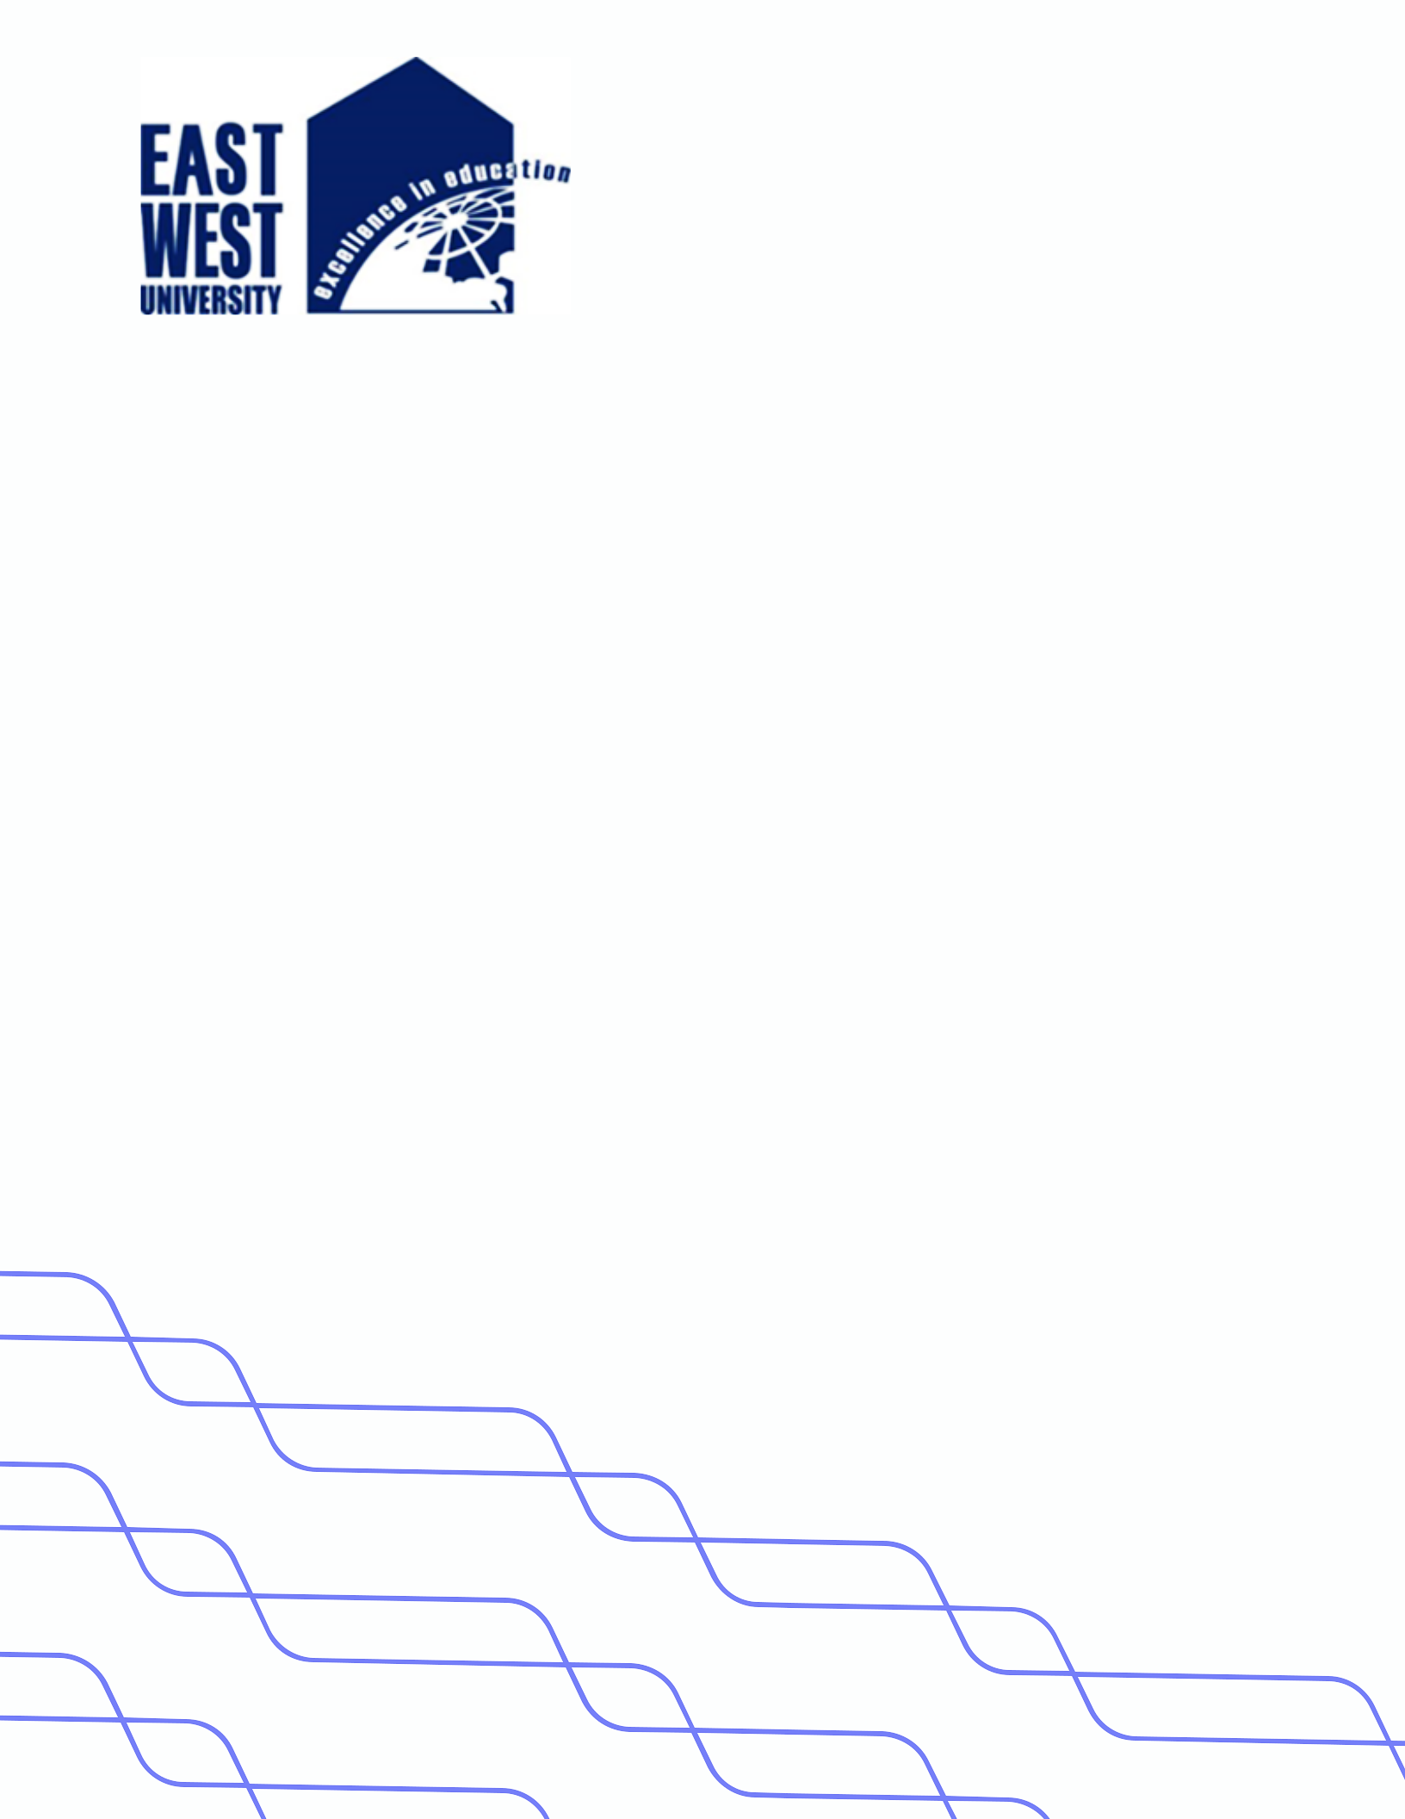

**LAB-03**

**Title: Algorithm to SORT ARRAY using BUBBLE SORT**

**Name: Azizul Abedin Azmi**

**ID: 2022-1-60-130**

**Section: 03**

**Course Code: CSE207**

**Course Title: (Data Structures)**

**Date: 19/02/2024**

**Course Instructor:**

**Dr. Anup Kumar Paul**

**Associate Professor**

**Department of Computer Science and Engineering**

**Source Code:**

**Main.java:**

package Lab03;

import java.util.Scanner;

public class Main {

    public static void main(String[] args) {

        int[] data = new int[10];

        Scanner input = new Scanner(System.in);

        System.out.println("Enter some data");

        for(int i=0;i<data.length;i++) {

            data[i] = input.nextInt();

        }

        BubbleSortingAlgorithm sort = new BubbleSortingAlgorithm(data);

        System.out.println("The array ");

        sort.BubbleSort();

        input.close();

    }

}

**BubbleSortingAlgorithm.java:**

package Lab03;

public class BubbleSortingAlgorithm {

    int[] data;

    int temp;

    public BubbleSortingAlgorithm(int[] data) {

        this.data = data;

    }

    public void BubbleSort() {

        for (int j=0; j<data.length-1; j++){

            for (int i=0; i<data.length-1-j; i++){

                if (data[i]>data[i+1]){

                    temp = data[i];

                    data[i]= data[i+1];

                    data[i+1]=temp;

                    printArray();

                }

            }

        }

    }

    public void printArray() {

        for(int element:data) {

            System.out.print(element + " ");

        }

        System.out.println();

    }

}

**Output:**

